EXPERIMENT 19
Implement the Erosion Morphological Operation Using OpenCV in Python
Aim:
To perform the Erosion morphological operation on an image using Python and OpenCV.
Procedure:
- Import OpenCV and NumPy libraries.
- Read the input image.
- Convert the image into grayscale.
- Create a kernel using np.ones().
- Apply erosion using cv2.erode().
- Display the original and eroded images.
Program:
import cv2
import numpy as np

img = cv2.imread('image.jpg', 0)

kernel = np.ones((5,5), np.uint8)

erosion = cv2.erode(img, kernel, iterations=1)

cv2.imshow('Original Image', img)
cv2.imshow('Erosion Image', erosion)

cv2.waitKey(0)
cv2.destroyAllWindows()
Input:

Output:
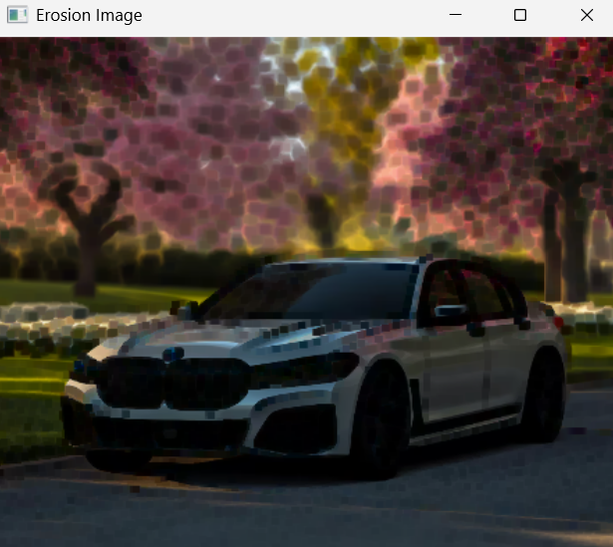
Result:
Thus, the Erosion morphological operation was successfully performed, reducing the foreground regions of the image.

